Monthly Market Commentary – 3.5.26
War in the Mideast
The U.S. and Israel launched an attack on Iran last weekend.
The U.S. did not move such a significant amount of military assets into the region to bluff. The arrival of the USS Gerald Ford aircraft carrier and F-22 Raptors were the final steps taken before the air strikes commenced on February 28th.
President Trump detailed the history of Iran’s aggression to the U.S. and highlighted the goals of the operation, which were to: 1) prevent Iran from building a nuclear bomb, 2) destroy Iranian missiles, 3) “annihilate” the Iranian Navy, and 4) urged Iranians, at the appropriate time, to retake their government.
While the elimination of Iran’s senior leadership occurred quickly, the success of this operation is not guaranteed and is fraught with risk over the next several weeks/months.
The uncertainty of war can weigh on sentiment for consumers, businesses, and investors. prolonged conflict in the Mideast can lead to higher oil prices, stalled economic growth, rising inflation, and consequently, weakness in the financial markets.
Of course, the human tragedy is great on many levels. Yet as stewards of our clients’ assets, we must take an objective approach, applying a combination of historical, technical, and fundamental analyses to best guide our clients through these challenging times.

Market History
A review of fifteen “crisis events” since Pearl Harbor shows the equity market, as defined by the S&P 500 Index, has displayed surprising resilience during historically difficult periods.
Chart 1 – Crisis Events and S&P 500 Performance
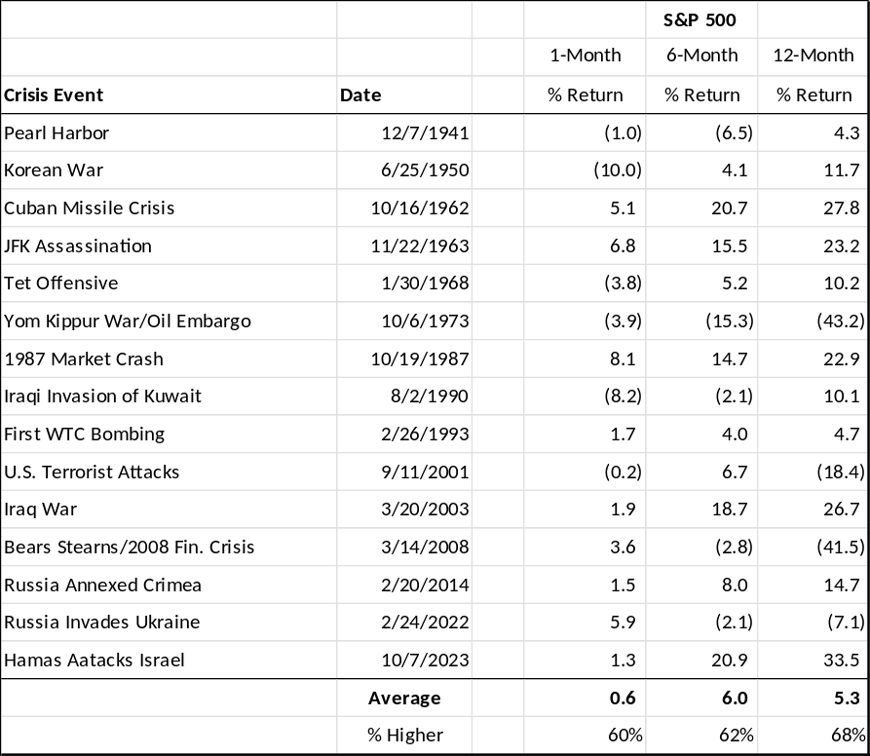
While volatility intensifies during the month following the crisis’ inception, trailing 6-month and 12-month returns for the S&P 500 on average are not only positive, but the Index is higher approximately two-thirds of the time over the ensuing year.
The two outliers in this study are the oil embargo in 1973 and the Great Financial Crisis (GFC) beginning in 2008. It should be noted that in 1973, the U.S. was a net oil importer, therefore heavily dependent on energy flows from the Mideast. Yet in 2026, the U.S. is a net exporter, therefore far less reliant on oil imports from producers in the affected region.
Another point on energy is that due to the improved domestic oil production capacity, even with recent volatility, the price of WTI oil is ~$75.00 per barrel and ~$20.00 less than the average price over the past 20 years, providing a degree of buffer for gasoline prices relative to prior periods of energy price spikes.
The other outlier for S&P 500 returns was not war-related, but rather due to the financial engineering of the U.S. mortgage market that contributed to the demise of both the housing and financial markets beginning in 2008. While these causes are not comparable with today’s geopolitical tensions, the response of favorable fiscal and monetary policies offer a blueprint for what may develop domestically should a prolonged Mideast conflict result.
Market Technicals
To be sure, after three years of double-digit percentage gains, the equity market has experienced a leadership rotation from growth and mega-cap technology to value with Energy, Industrials, Materials and Consumer Staples.
In addition, the equity market, as defined by the S&P 500, has been hovering in a relatively narrow range, trading between 6800 – 7000 in 2026, with new records proving elusive and as buyers emerge at the bottom of this range.
Chart 2 – S&P 500 Index

The resistance at the 7,000 level can be attributed to a variety of factors, but technically speaking, the Index was beginning to exhibit signs of exhaustion toward the end of 2025, with defensive leadership and a moderation in relative strength measures. The heightened geopolitical tensions have magnified these trends, and the percentage of stocks trading above their 50-day moving average (~57%) and 200-day moving average (~63%) have been in decline during the first week in March.
As the equity market had grown less dependent on growth and mega-cap tech, the equal-weighted S&P 500 Index closed February at a new record high. Though we expect volatility to persist in the weeks ahead, a cluster of support for the cap-weighted S&P 500 hovers in the 6,500-6,600 range, which corresponds with its upward sloping 200-DMA. Should that level fail to hold during periods of intensified volatility, last summer’s breakout zone of 6,200 may provide longer-term support for the Index.
Market Fundamentals
From a macro perspective, several tailwinds may help to provide support during the current volatility.
Indeed, the One Big Beautiful Bill Act (OBBBA) is poised to provide significant fiscal tailwinds beginning in early 2026.

For example, over the past three years, Strategas Research Partners notes that federal tax refunds averaged ~$360 billion annually. In 2026, though, investors can expect up to a 40.0% increase (~$150 billion) to ~$515 billion in consumer tax refunds. This equates to an average individual refund growing from ~$2,250.00 in 2025 to an estimated $3,225.00 per non-farm payroll worker in 2026.

Chart – Federal Tax Refunds

Moreover, businesses can expect up to $135 billion in refunds, while also benefitting from incentives like immediate expensing and reduced regulatory burdens, which should combine to support capital investment this year.
In addition, monetary policy can remain supportive, even as the Federal Reserve may pause on rate cuts at their next meeting. This is because monetary officials intend to expand the Fed’s balance sheet by approximately $40 billion per month this year, essentially forcing market interest rates lower as they buy Treasury securities. This should prove a powerful combination with tax refunds, particularly since affordability is a theme during this midterm election year.
Finally, corporate profits remain solid, a pattern that is forecast to continue.
FactSet reports that operating earnings for companies in the S&P 500 climbed 14.2% in the fourth quarter, with consensus expectations for an additional 14.7% profit growth for the Index in 2026.
A benefit of the S&P 500's range-bound trading in 2026 is that profits now have a chance to catch up with stock valuations from the past year. This is consistent with our view that equity market gains will approximate profit growth, rather than expanded valuations, in 2026.
Conclusion
While the rise in geopolitical tensions and war in the Mideast are troubling developments, we believe it is important for investors to adhere to their longer-term strategic asset allocations during periods of heightened market volatility.
To be sure, there is strong historical data supporting “time in” the markets, rather than “timing” the markets. Since the onset of WWII, previous crises have been met with initial volatility, only for markets to stabilize in the ensuing months. The current technical backdrop offers several areas of support for the equity market, as the S&P 500 Index has broadened participation and expanded its leadership in recent months. Fundamentals are also supportive, with tax refunds, market interest rates, and corporate profits all headed in favorable directions.

